|  |
| --- |
|  |
| User Manual |
|  |
| Clinical Support System |

**BIOCORE LAB UTEM**

November 27, 2015

Authored by: Amalina

User Manual

Clinical Support System

1. Login

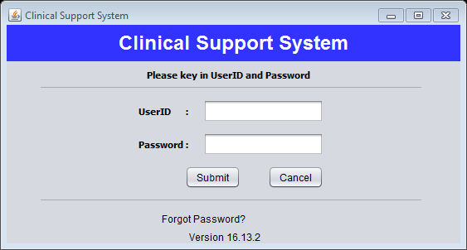

**2**

**1**

Figure 1

**Step 1:** Fill in the text fields with details needed.

**Step 2:** Click “Submit” button.

1. Forgot Password

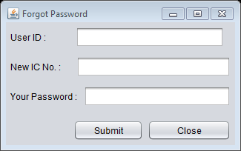

**2**

**1**

Figure 2

**Step 1:** Fill in the text fields with details needed.

**Step 2:** Click “Submit” button.

1. Logout

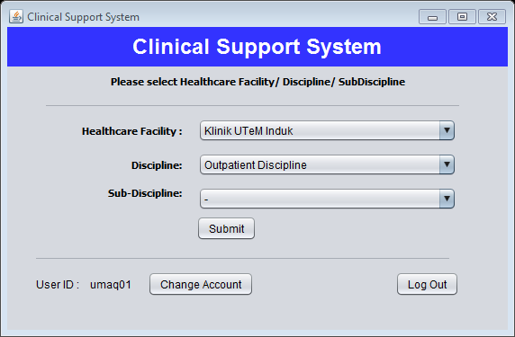

**1**

**Step 1:** Click “Log Out” button.

1. Change Account



**1**

**Step 1:** Click “Change Account” button. User profile will be display.

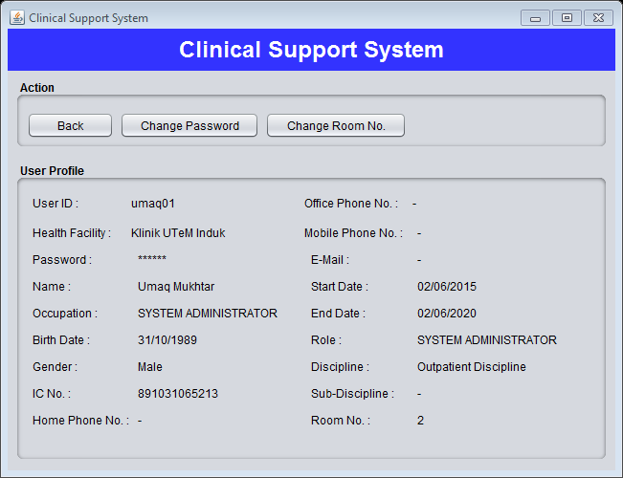

**2**

**Step 2:** To change user password click “Change Password” button. Figure below will be display.

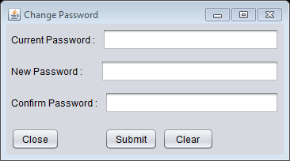

**5**

**4**

**3**

**Step 3:** Fill the text fields.

**Step 4:** Click “Submit” button to submit.

**Step 5:** Click “Close” button to close the menu.



**6**

**Step 6:** Click “Change Room No.” button to change user room number. Then figure below will be display.

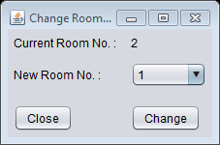

**9**

**8**

**7**

**Step 7:** Select new room number.

**Step 8:** Click “Change” button to save.

**Step 9:** Click “Close” button to close the menu.

1. Main Menu



**2**

**1**

**Step 1:** Select the item.

**Step 2:** Click “Submit” button to go to the main menu page.

1. Human Resource

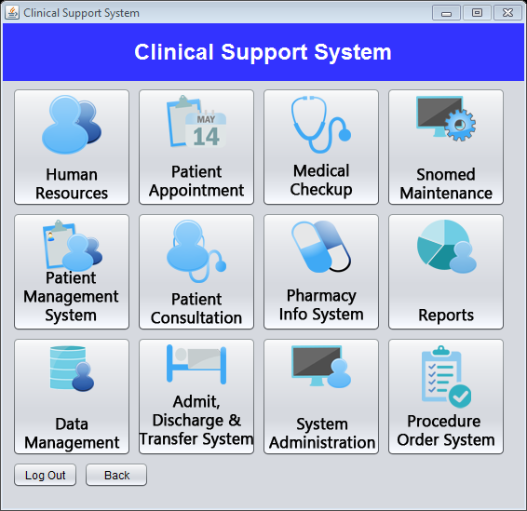

**1**

**Step 1:** Click “Human Resource” button.

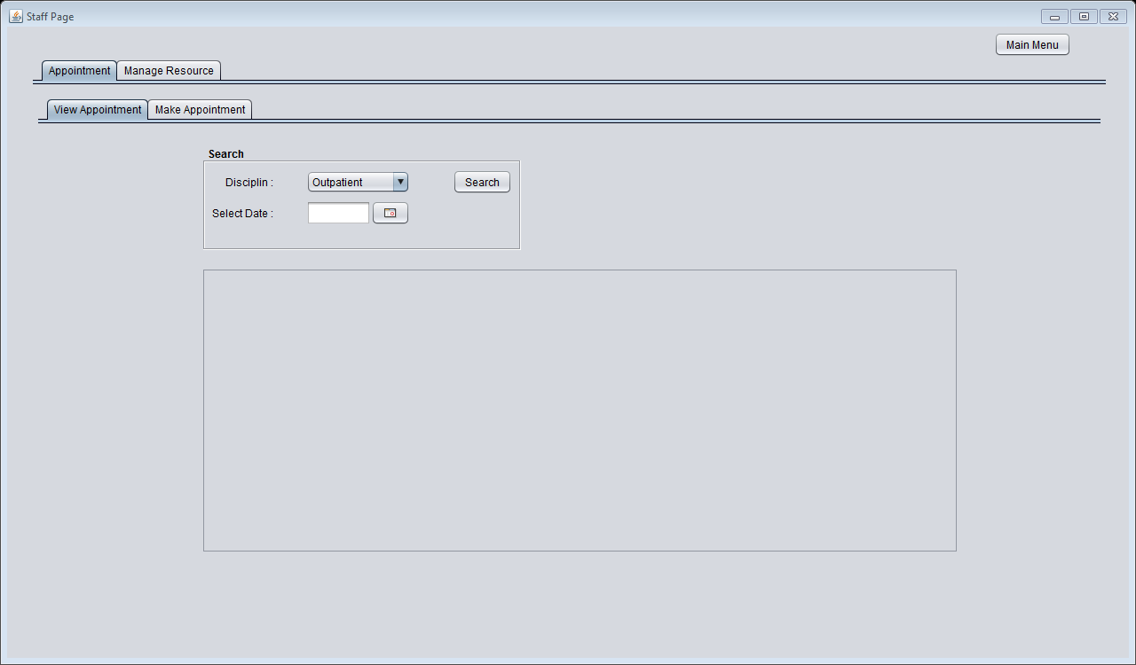

**5**

**4**

**3**

**2**

**6**

**Step 2:** Click “Appointment” menu bar to manage about appointment.

**Step 3:** Click “View Appointment” to view appointment by searching date.

**Step 4:** Select the type of Disciplin and select the date. After that push the “Search” button. Result will be display.

**Step 5:** Click “Make Appointment” menu bar to make a new appointment.

**Step 6:** Click “Main Menu” button to go to the main menu.

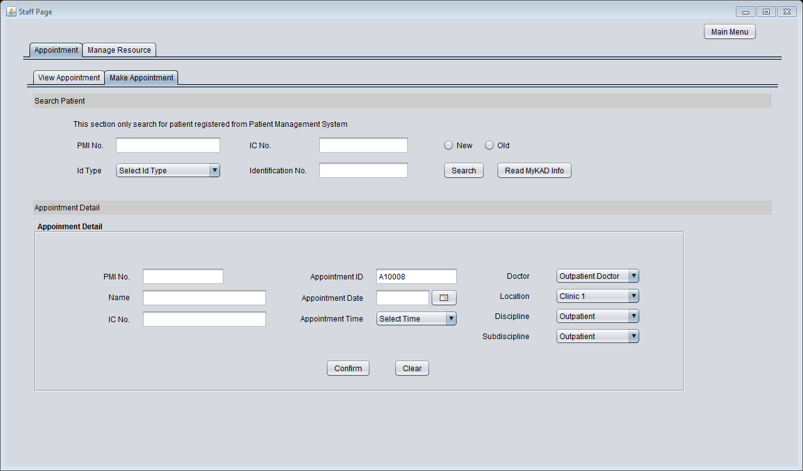

**11**

**10**

**9**

**8**

**7**

**Step 7:** Fill the text fields at search area to select patient.

**Step 8:** Click “Search” button after insert details needed. Patient details will appears in Appointment detail.

**Step 9:** Fill the appointment detail.

**Step 10:** Click “Confirm” button to confirm appointment details.

**Step 11:** Click “Manage Resource” menu bar to manage doctor.

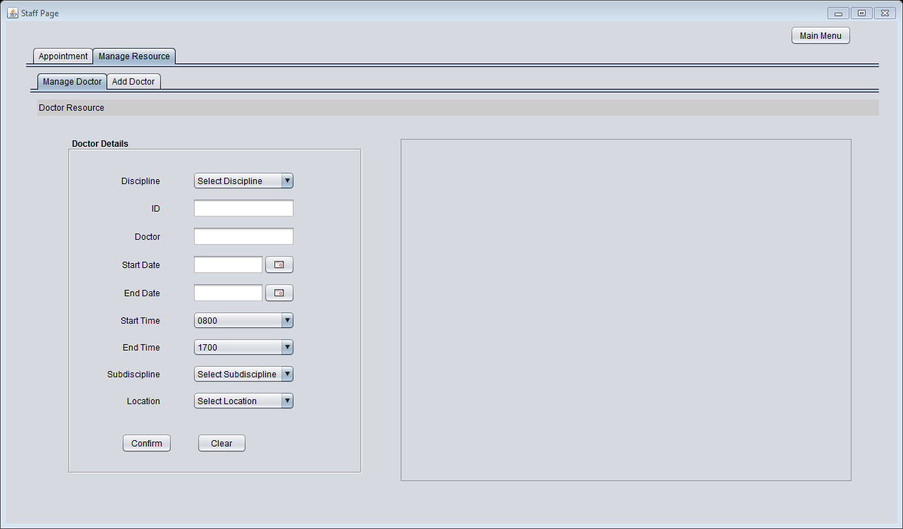

**13**

**15**

**14**

**12**

**Step 12:** Click “Manage Doctor” menu bar to manage doctor resource.

**Step 13:** Fill in the doctor details.

**Step 14:** Click “Confirm” button to insert doctor resource.

**Step 15:** Click “Add Doctor” menu bar to add doctor.

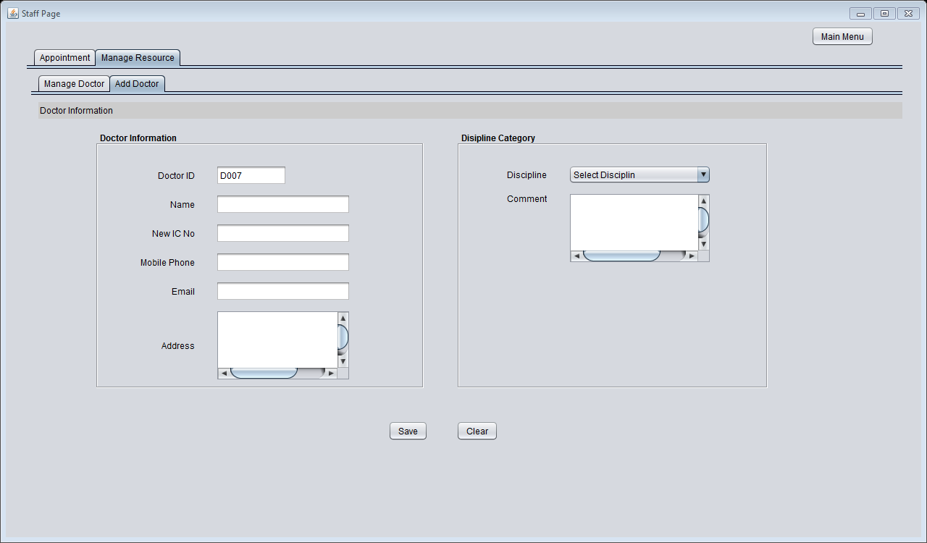

**17**

**18**

**16**

**Step 16:** Click “Add Doctor” menu bar to add doctor.

**Step 17:** Fill the text fields.

**Step 18:** Click “Save” button to keep the details.

1. Patient Appointment



**1**

**Step 1:** Click “Patient Appointment” button.

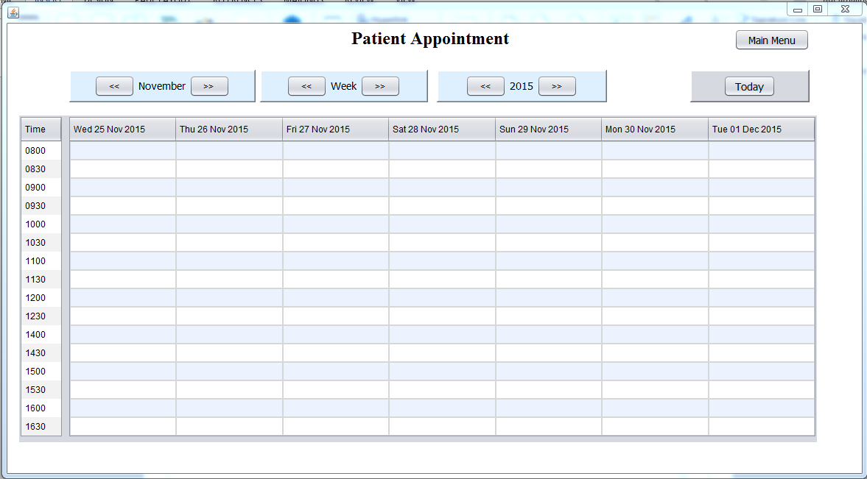

**9**

**5**

**2**

**3**

**4**

**6**

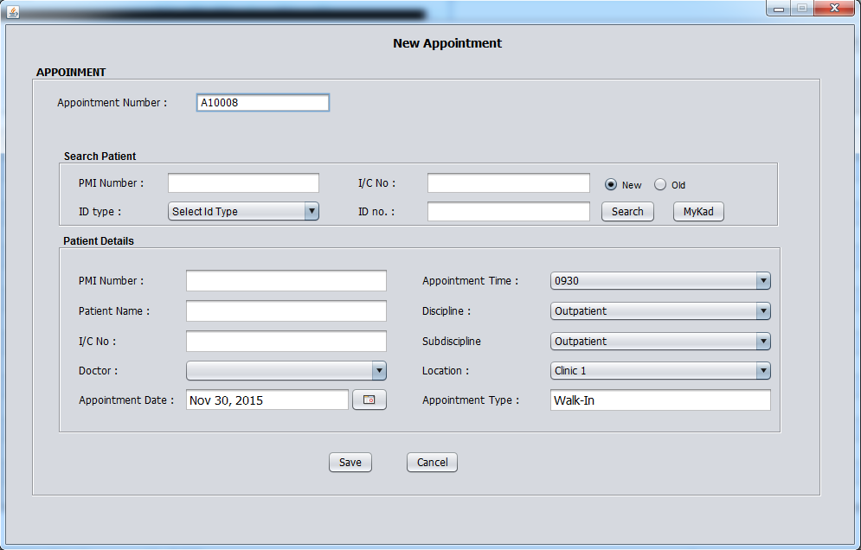

**8**

**7**

**Step 2:** Click “Previous” or “Next” button to change month.

**Step 3:** Click “Previous” or “Next” button to change week.

**Step 4:** Click “Previous” or “Next” button to change year.

**Step 5:** Click “Today” button to go to current date.

**Step 6:** Double click at column to add, edit or delete an appointment.

**Step 7:** Fill the form.

**Step 8:** Click “Save” button to add new appointment or edit appointment. Click “Delete” button to delete appointment.

**Step 9:** Click “Main Menu” button to go to main menu.

1. Medical Checkup



**1**

**Step 1:** Click “Medical Checkup” button.

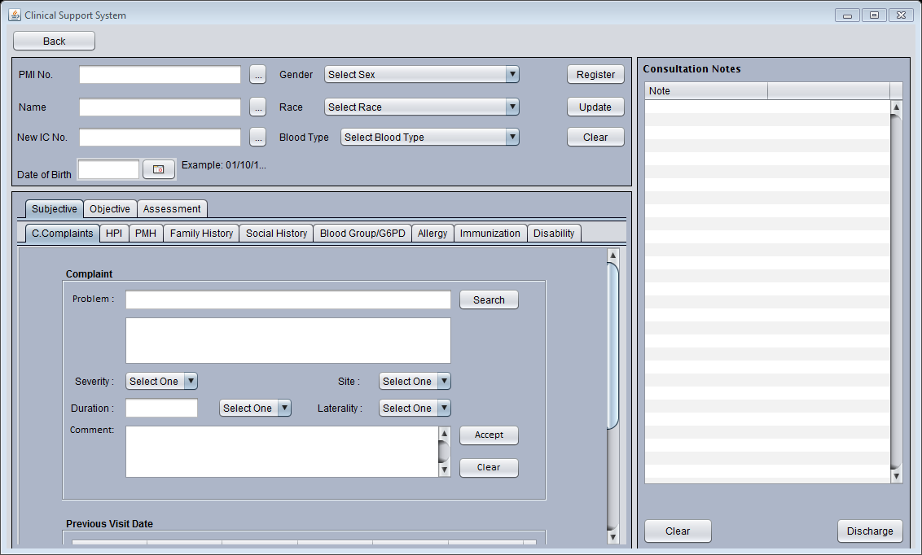

**5**

**4**

**3**

**2**

**1**

**Step 2:** Click “Previous” or “Next” button to change month.

**Step 3:** Click “Previous” or “Next” button to change week.

**Step 4:** Click “Previous” or “Next” button to change year.

**Step 5:** Click “Today” button to go to current date.

**Step 6:** Double click at column to add, edit or delete an appointment.

**Step 7:** Fill the form.

**Step 8:** Click “Save” button to add new appointment or edit appointment. Click “Delete” button to delete appointment.

**Step 9:** Click “Main Menu” button to go to main menu.

1. Snomed Maintenance



**1**

**Step 1:** Click “Snomed Maintenance” button.

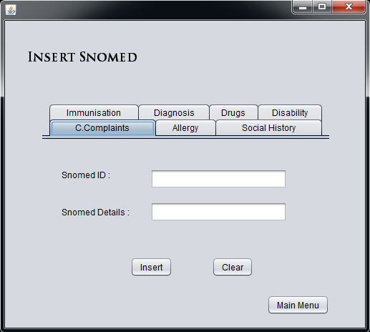

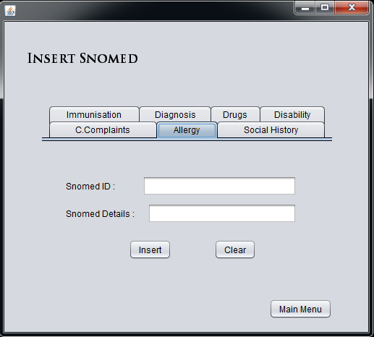

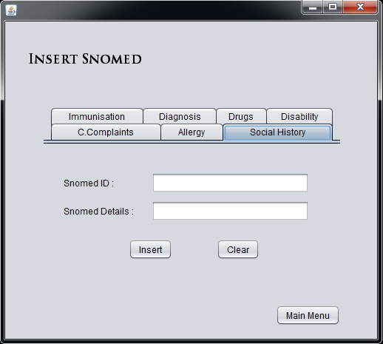

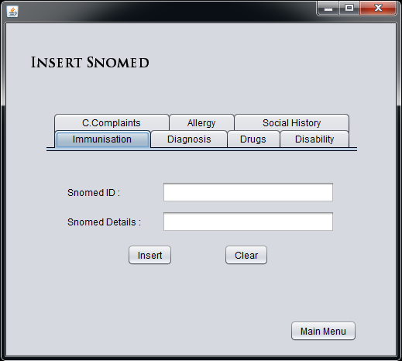

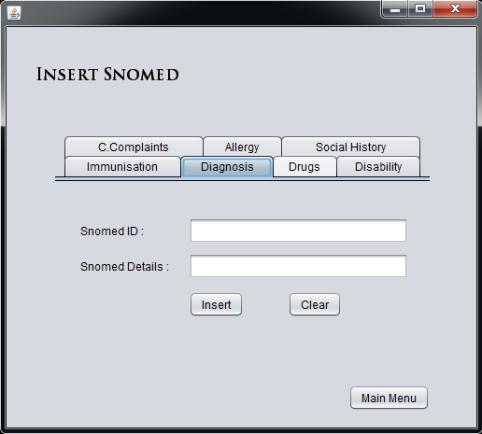

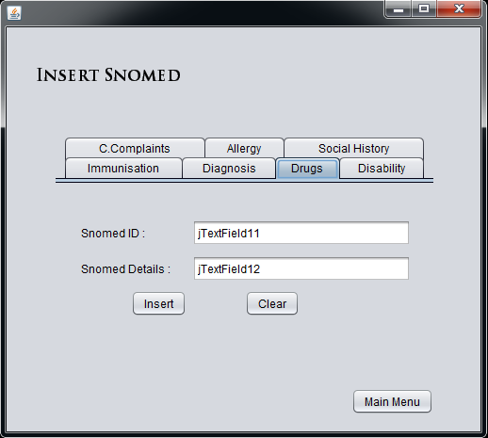

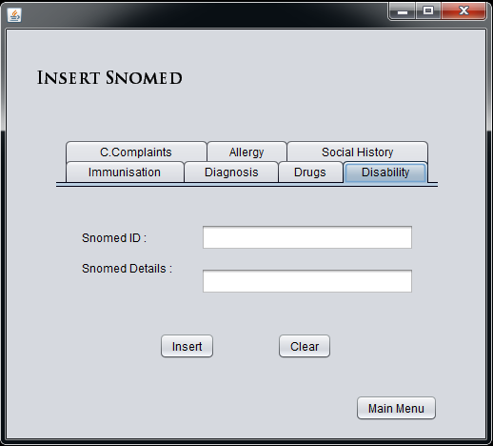

1. Patient Management System



**1**

**Step 1:** Click “Patient Management System” button.

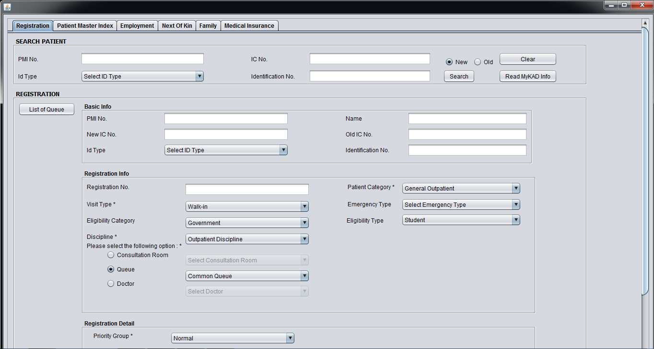

**7**

**5**

**4**

**3**

**2**

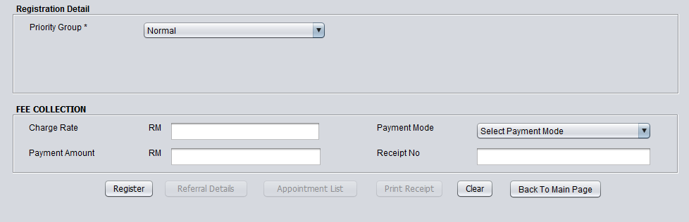

**6**

**5**

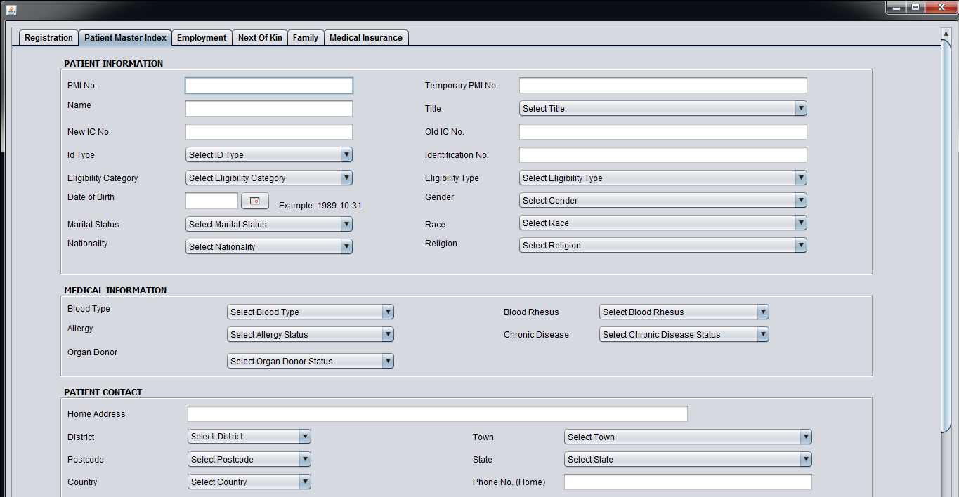

**8**

**9**

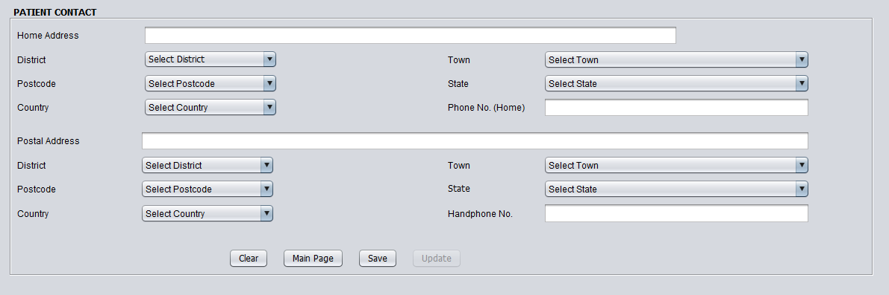

**10**

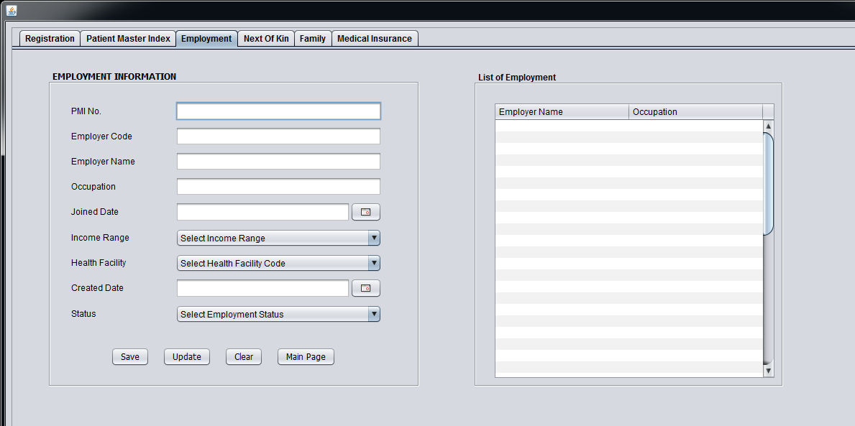

**13**

**12**

**11**

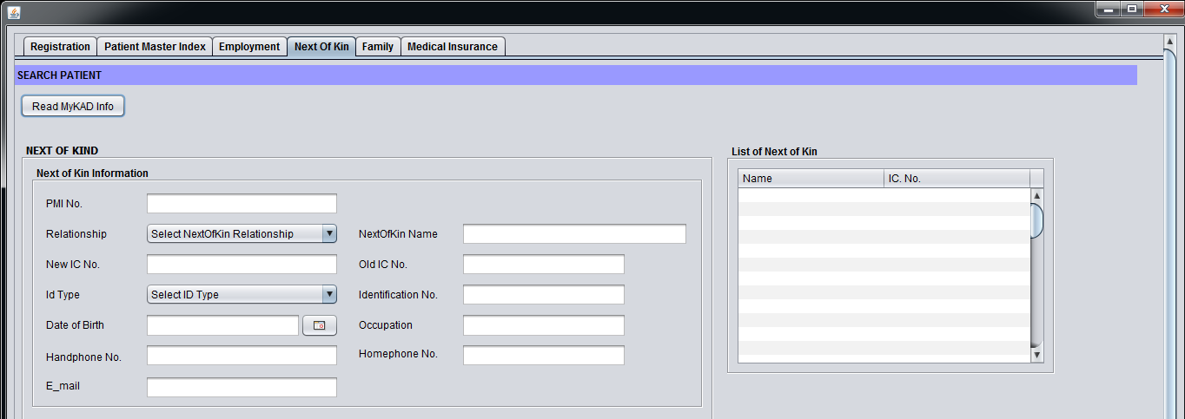

**15**

**14**

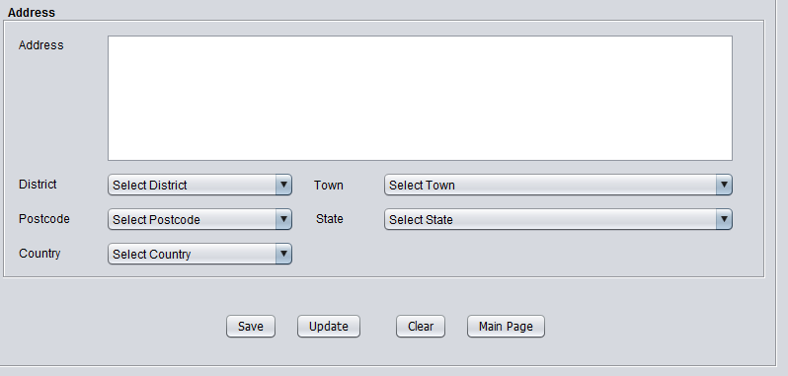

**16**

**17**

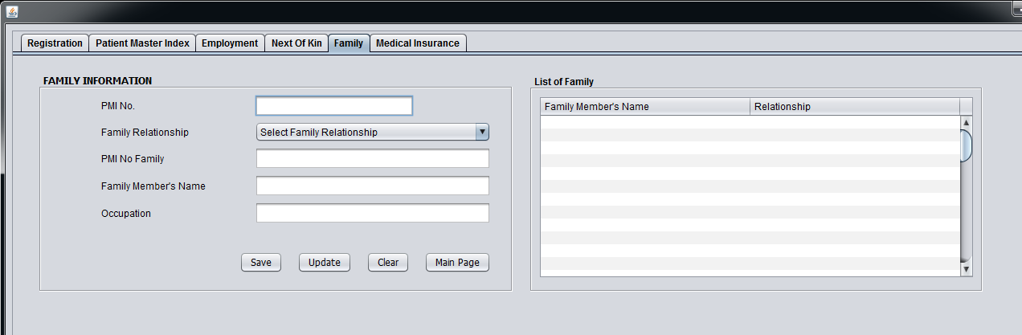

**18**

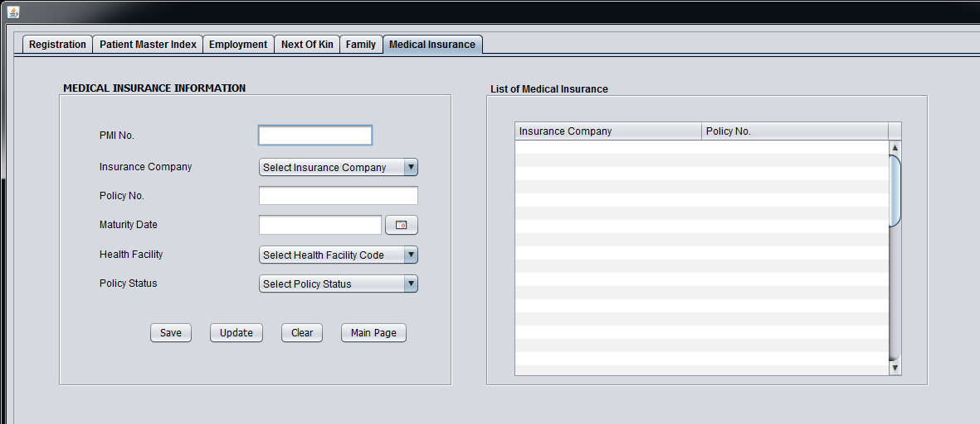

1. Patient Consultation



**1**

**Step 1:** Click “Patient Consultation” button.

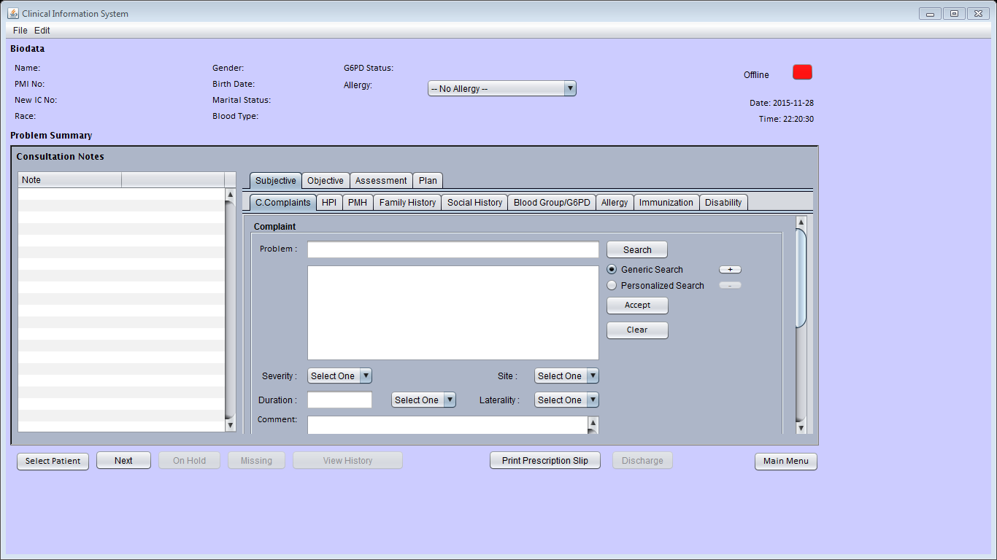

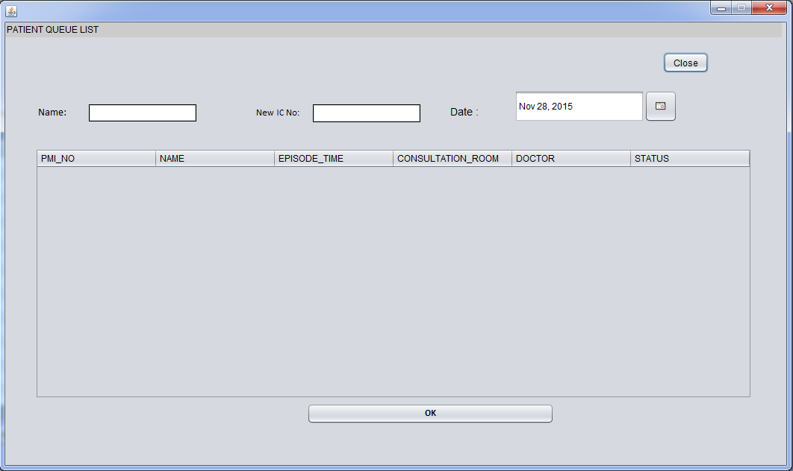

1. Pharmacy Info System



**1**

**Step 1:** Click “Pharmacy Info System” button.

1. Reports



**1**

**Step 1:** Click “Reports” button.

1. Data Management



**1**

**Step 1:** Click “Data Management” button.

1. Admit, Discharge and Transfer System



**1**

1. **Step 1:** Click “Admit, Discharge and Transfer System” button.
2. System Administration



**1**

1. **Step 1:** Click “System Administration” button.
2. Procedure Order System



**1**

1. **Step 1:** Click “Procedure Order System” button.